ACDM October Newsletter
Developments that tackle climate change could avoid having to get planning permission, under proposals being considered by the Scottish government.

Under Proposals being considered by the Scottish government, projects that have a direct impact on fighting climate change will immediately be given planning permission. These projects include things such as renewable energy projects and EV charging stations.

Planning Minister Kevin Stewart said: "Planning has a key role to play in addressing climate change and radically reducing our emissions.” “Removing red tape from some of the highest priority projects can be a big step towards our goal of a net-zero carbon future.”

https://www.bbc.co.uk/news/uk-scotland-49871275
https://www.scotsman.com/business/green-developments-in-scotland-could-proceed-without-planning-permission-1-5013849

Waterotor – Slow moving water Turbine

One of the issues that has always faced hydro electric generators is the flow rate of the body of water they are installed in. Many systems require fast flowing rivers or large drops in order to generate electricity. Waterotor Technologies Inc. have developed a turbine designed specifically for slow moving rivers with lower flow rates. The system only requires a minimum water speed of 2mph (3.2km/hr / 0.9 m/s) with an optimum operating speed of roughly 4mph (6.4km/hr / 3m/s) whereas a large number of other products require minimum speeds of at least 6.6mph (11km/hr / 3m/s). the system currently comes in 2 sizes with a third larger planned but still in development, 1kW 10kW and 1MW.
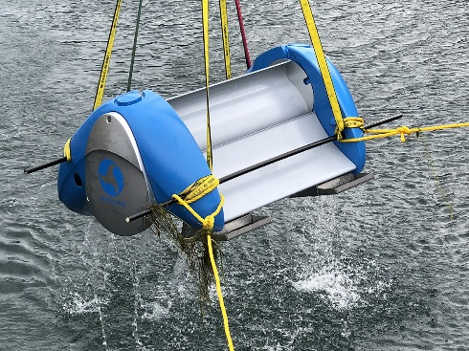
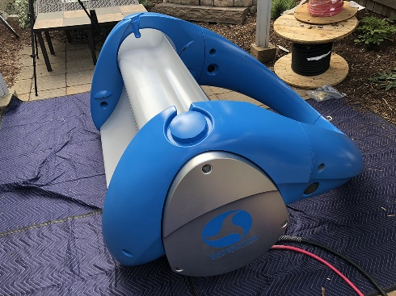

The 1kW system requires a depth of 112cm/44inch water to be installed and the 10kW system requires to be submerged at least 1.5x the height of the rotor. System sizes are based at the optimum speed of 4mph. The system can work in temperatures from +1C up to 50C with no problems making the system viable in almost any slow moving body of water worldwide. For more information on the product visit their website which has more detailed product specifications and videos showing the system in operation.

Waterotor Technologies Inc website - https://waterotor.com/

Brexit Health and Safety Impacts

Many businesses have been left in uncertainty with Brexit looming. Without a deal in place at the time of writing many are left unsure how this will affect their day to day operations.

Health and safety is luckily one of the aspects of day to day working that will not be affected by Brexit no matter wat the deal, or lack thereof, happens to be. UK health and safety is a world leader in the field with some of the lowest fatalities at work worldwide and the lowest in the EU. The UK has achieved this because they do not take its health and safety legislation from the EU but from independent UK based studies and lawmakers. This means that companies will not need to update their policies in the wake of Brexit. 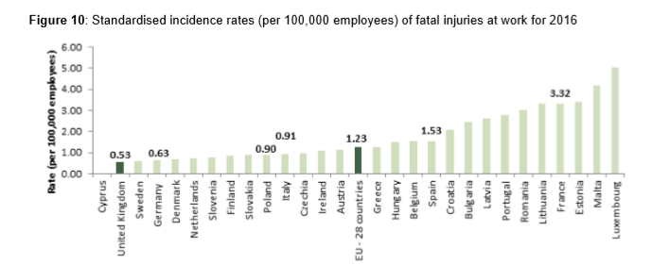
Source – workplace fatal injuries in Great Britain, 2019 – HSE published 03/07/19
HSE Brexit page –
https://www.hse.gov.uk/brexit/index.htm#utm_source=hse.gov.uk&utm_medium=refferal&utm_campaign=EU-Exit&utm_content=home-page-news

CITB test centres raided and shut down

Following unannounced visits on three test centres in Cheshire, London and Essex by CITB, the police and the home office 10 people have been arrested, 7 construction workers and 3 for involvement in the fraud.

Some candidates have admitted to police to be paying up to £500 for the answers to the HS&E test which typically costs just £21. Several of the candidates were also suspected to be in the country illegally and were detained by the Home office. It is suspected that these fraudulent tests were a part of a larger human trafficking scheme that provided buyers with opportunities for work. This often left the trafficked people in debt to the gang leaders.

So far in 2019 CITB has shit down 17 test centres that have been found to be partaking in the delivery of fraudulent tests or CITB certificates. CITB have announced that they will review just over 2,500 tests conducted by the three centres visited in the last year and decide whether or not to revoke them.

More information here -
http://www.constructionmanagermagazine.com/news/ten-detained-citb-test-centre-raids/

Mental Illness Awareness Week
Mental illness awareness week took place this month and ran from Sunday the 6th to Sunday the 12th. Mental Illness can often go unnoticed and many prominent figures in society adopted the tag “it’s ok to not be ok” in effort to persuade more people to open up about their feelings and seek help.
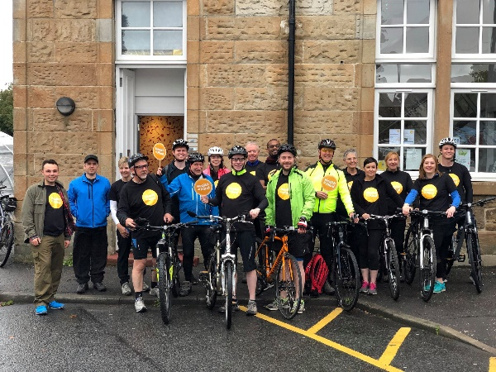
On the 4th of October Alliance CDM were proud to be a part of the fund raising effort organised by Slorach wood Architects for a local Mental Health charity Health in mind, an Edinburgh based charity that does great work throughout the Lothians, including South Queensferry, to promote positive mental health and wellbeing by providing a wide range of services. Not only do they provide trauma counselling for individuals, they offer peer to peer collaboration with support groups and befriending programmes.

At the time of writing we are very close to achieving our fundraising goal and the just giving page is still open for any who wish to donate. Each and every donation is appreciated by us as well as those who suffer and require help.

Just giving - https://www.justgiving.com/fundraising/forthonthe4th
Health in mind Page - https://www.health-in-mind.org.uk/
Mental health foundation - https://www.mentalhealth.org.uk/

Alliance CDM
The Station Master’s Office
Station Road
South Queensferry
EH30 9JP
TEL: 0131 319 2100
www.alliancecdm.co.uk

