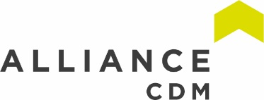
ACDM Newsletter
Algae Bio Reactor
This Month marked a historic climate change meeting organised by the UN and attended by 60 world leaders. Many world leaders have put forward more radical plans to reduce carbon emissions and even Jeff Bezos (Amazon founder and CEO) has announced a plan to be carbon neutral by 2030.

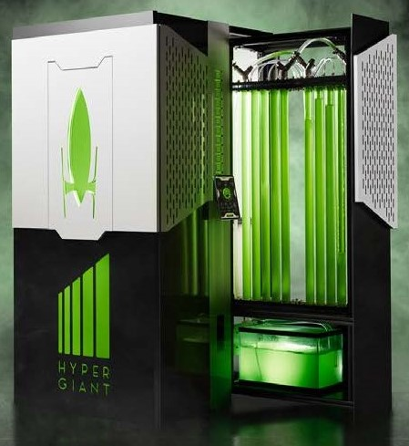
In the wake of this we would like to highlight a technology which can not just capture carbon from the atmosphere but produce usable materials. The tech company Hypergiant have developed an algae bio reactor which can capture as much carbon as an acre of trees. The system takes in air either through an open surface or through building exhaust which is bubbled into the main tank to diffuse into the water/algae. The algae then use either natural light from the sun or artificial light to produce biomass which can be harvested and processed to create fuel, oils, nutrient-rich high-protein food sources, fertilizers, plastics, cosmetics and more. Hyper giant claim that up to 90 % of the C02 pumped through the system will be removed from the air and the output will be clean fresh oxygen. The enter system is ran by a purpose-built AI so that the system can run completely autonomously with the only human input being routine maintenance.

Hypergiant Bio reactor page - https://www.hypergiant.com/green/
Working safely with display screen equipment
At Alliance CDM we work closely with Design teams who like ourselves do a lot of their work on a computer so spend a lot of their days looking at screen. If left unchecked workers can suffer fatigue, eye strain, upper limb problems and backache from poorly designed workstations or work environments.
So what can you do to reduce your risks?
“Get comfortable”
- Forearms should be approximately horizontal, and the user’s eyes should be the same height as the top of the screen.
- Make sure there is enough workspace to accommodate all documents or other equipment. A document holder may help avoid awkward neck and eye movements.
- Arrange the desk and screen to avoid glare, or bright reflections. This is often easiest if the screen is not directly facing windows or bright lights.
- Adjust curtains or blinds to prevent intrusive light.
- Make sure there is space under the desk to move legs.
- Avoid excess pressure from the edge of seats on the backs of legs and knees. A footrest may be helpful, particularly for smaller users.
Well-designed workspace
Keyboards and keying in (typing)
- A space in front of the keyboard can help you rest your hands and wrists when not keying.
- Try to keep wrists straight when keying.
- Good keyboard technique is important – you can do this by keeping a soft touch on the keys and not overstretching the fingers.
Using a mouse
- Position the mouse within easy reach, so it can be used with a straight wrist.
- Sit upright and close to the desk to reduce working with the mouse arm stretched.
- Move the keyboard out of the way if it is not being used.
- Support the forearm on the desk, and don’t grip the mouse too tightly.
- Rest fingers lightly on the buttons and do not press them hard.
Reading the screen
- Make sure individual characters on the screen are sharp, in focus and don’t flicker or move. If they do, the DSE may need servicing or adjustment.
- Adjust the brightness and contrast controls on the screen to suit lighting conditions in the room.
- Make sure the screen surface is clean.
- When setting up software, choose text that is large enough to read easily on screen when sitting in a normal comfortable working position.
- Select colours that are easy on the eye (avoid red text on a blue background, or vice versa)
From time to time you should also stretch and change position, look into the distance and blink often, change activity before you get tired rather than after, take short frequent breaks.

More information is available from the HSE guidance.
HSE Guidance -https://www.hse.gov.uk/msd/dse/#utm_source=hse.gov.uk&utm_medium=refferal&utm_campaign=new-top-tasks&utm_term=dse&utm_content=news-page

Sponsored Cycle – Forth on the 4th

Alliance CDM are partnering with our sister company Slorach Wood Architects to raise money for an Edinburgh based mental health charity, Health In Mind. Our Cycle will take us across the Forth Road Bridge, through the villages of Fife, across the Kincardine bridge and back to Dalmeny. There will also be a 10 mile walk through the Dalmeny Estate for those who prefer to keep their feet on the ground.

Health in Mind, who work specifically throughout Edinburgh and the Lothians, including South Queensferry, to promote positive mental health and wellbeing by providing a wide range of services. Not only do they provide trauma counselling for individuals, they offer peer to peer collaboration with support groups and
befriending programmes.

Those who struggle with mental health often do so alone and with little or no support. Through fundraising and donating over the next year we will not only allow Health in Mind to continue their invaluable work, we hope that it may help local people find the support when they need it.

Health in Mind website - https://www.health-in-mind.org.uk/
Just giving page – https://www.justgiving.com/fundraising/forthonthe4th
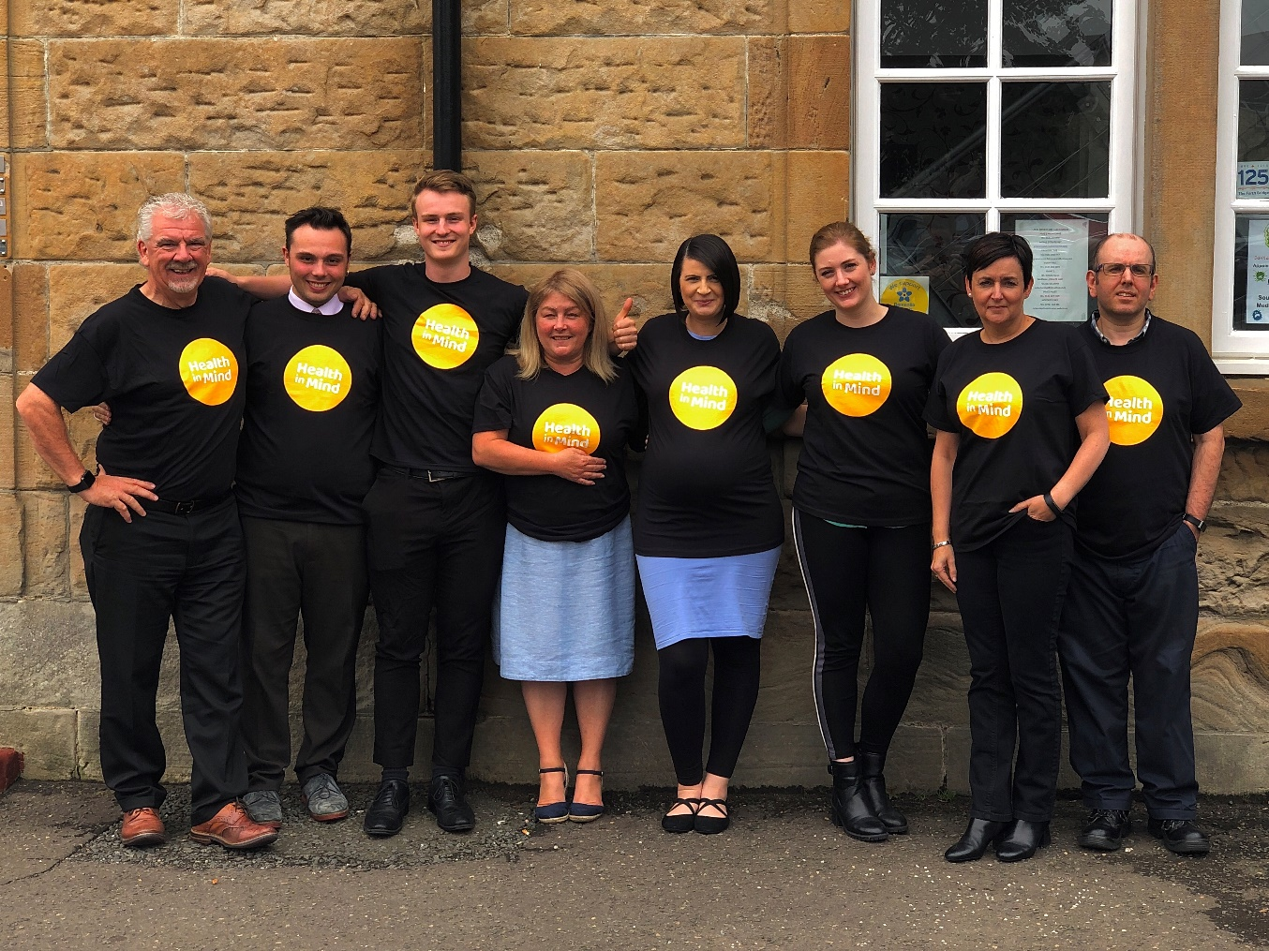
Alliance CDM
The Station Master’s Office
Station Road
South Queensferry
EH30 9JP
TEL: 0131 319 2100
www.alliancecdm.co.uk

