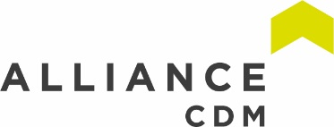
ACDM December Newsletter
Airtight on Asbestos Report

A recently published report on asbestos conducted by ResPublica as a part of their “Airtight on Asbestos” campaign show that there are elevated risks in an alarming number of schools and hospitals. It was estimated that as many as 94% of our hospitals still contain asbestos and as many as 80% of schools. This adds up to an estimated 6 million tonnes of asbestos spread out across 1.5 million buildings. That’s 4 tonnes on average per building.

However, asbestos does come in three types, chrysotile (white), amosite (brown) and crocidolite (blue). Each type is more dangerous than the last as they get dustier and more toxic with chrysotile being the ‘safest’ and crocidolite being the most dangerous. It is possible that the vast majority of the asbestos is chrysotile which is relatively safe as long as it is undamaged, monitored and maintained correctly.

With this said, the report found that nurses and teachers are on average 3 to 5 times more likely to develop mesothelioma than the general UK population. This is partially due to the amount of asbestos still in our schools and hospitals but also partially due to our methods of measuring airborne asbestos as well as our acceptable levels. Methods used in France, Germany and the Netherlands can be 10 times more accurate than current methods we use. On top of that our acceptable limits are 10 times that of Germany. This means where a child in Germany could inhale up to 10,000 fibres a day this figure could be up to 100,000 for a child in the UK.

The report makes some recommendations as follows:

- Government should bring the Health & Safety regime for the management of asbestos up to the highest international standards, as currently practiced in Germany, the Netherlands and France.
- Government should establish a central register of all asbestos currently in place in public buildings across the UK (including schools, hospitals and social housing). This should identify precise location, type and condition. We suggest that this duty, alongside appropriate resources and capability, should be devolved to the local authority level.
- Government should commission a cost-benefit analysis for the removal of all asbestos from public buildings in the UK. In turn, it should commit to a frame for phased removal on the basis of danger and risk to public health.

- The Health and Safety Executive should revise the current ‘Duty to Manage’. The practice and evidence that has emerged in the last two decades shows that complexity works against compliance. In addition, raised awareness amongst duty holders and those working in premises containing asbestos is urgently required to strengthen compliance

- The Health and Safety Executive should amend guidance and risk assessments to take account of:
a) Early exposure (e.g. children in school and social housing)
b) Different levels of ‘in-situ’ risks (e.g. secondary schools and social housing double the risk; primary schools quadruple the risk)
c) The higher risks posed by Amosite and Crocidolite, to ensure they are properly acknowledged and accepted within the Health and Safety Executive’s risk assessment.

- The Health and Safety Executive should accurately measure and represent fatality figures and the actual harm caused by asbestos exposure by:
a) Including all those who have died from mesothelioma over the age of 74 in occupational statistics
b) Including statistics for support staff who work in schools (caretakers, cleaners and secretaries, etc.)
c) Ensuring that, where death is attributable to mesothelioma, efforts are made to capture all past occupations, beyond that stated on the death certificate.

- The Health and Safety Executive should assure (rather than assume) buildings are safe, through the requirement for periodic sensitive air monitoring based upon revised risk and priority assessment. The Health and Safety Executive, in line with the best international practice, should use electron microscopy to measure airborne fibres up to 0.0001 f/cm3. These tests should take place when the buildings are in use.

- The Health and Safety Executive should improve the regime for reporting the disturbance of asbestos materials and ensure that the reporting regime in schools reflects that children are both:
a) At greater risk of harm due to exposure, and
b) Liable to disturb asbestos-containing materials.

- Research funding bodies in the UK should consider the current gaps in the academic literature about the risk asbestos-containing materials pose in-situ, and particularly:
a) The degree of harm asbestos exposure causes in children compared to adults
b) The degree to which damaged asbestos poses an increased risk of fibre release and the methods that can be used to suppress this
c) The efficacy of contemporary legislation and where this legislation is sub-optimal.

Download the report here: https://www.airtightonasbestos.uk/research
Wind Trees
Innovation in renewable energy comes in all shapes and sizes. The practicality of micro wind has always been in question as most traditional methods of delivering this proved to be too costly for the amount of energy produced. This was often due to average wind speeds in an area being below the minimum wind seed for the system meaning that the majority of the time the system had no output.

New World Wind are a French company that have developed a small micro wind generator they call the Aeroleaf. This system has a very small starting threshold of 2.5m/s (5.6mph) and a max of 43 m/s(96mph). The concept can also be combined with solar panels in a system they call the ‘Aeroleaf Hybrid’. One small generator has a very small output and is designed to be installed as part of a larger system they call ‘Wind Trees’ or the ‘Wind Bush’.
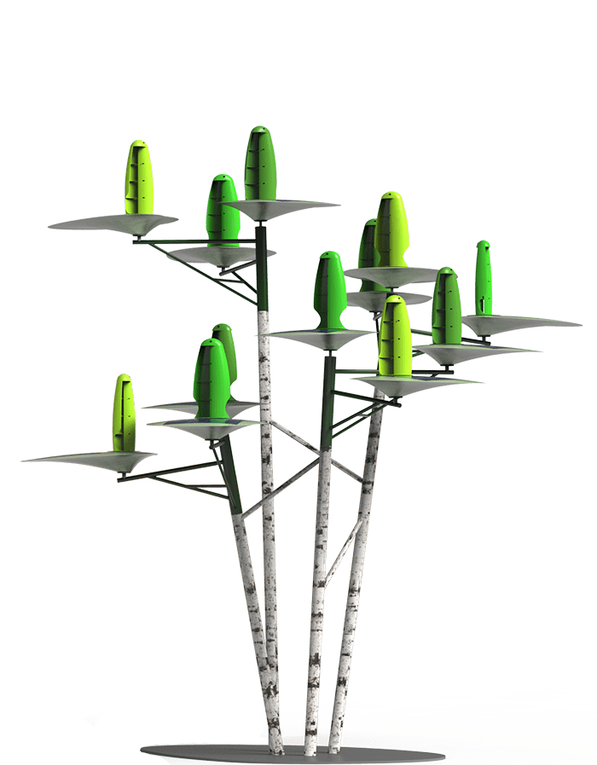
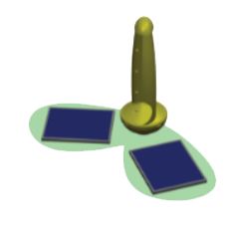

The wind tree model is their most expensive model with the highest output with an installed power of 10.8 kW and a nominal power of 5.868 kW. The company boasts that over the course of one year the average power production of the wind tree system produces enough power to light 15 street lights; or power an electric vehicle for 16,364 km; or provide 100 m² of low energy use office space; or provide 83% of a French households consumption outside of air conditioning. This power generation is the equivalent of burning 864kg of coal or 615 litres of fuel. This could save up to 2.4 tonnes of C02 every year (depending on the carbonisation of the local grid) from being produced every year.

Find out more on their website - http://newworldwind.com/en/
Dangers of Sleep Deprivation and Fatigue

Fatigue refers to the issues that arise from excessive working time or poorly designed shift patterns. It is generally considered to be a decline in mental and/or physical performance that results from prolonged exertion, sleep loss and/or disruption of the internal clock. It is also related to workload, in that workers are more easily fatigued if their work is machine-paced, complex or monotonous.

Fatigue results in slower reactions, reduced ability to process information, memory lapses, absent-mindedness, decreased awareness, lack of attention, underestimation of risk, reduced coordination etc. Fatigue can lead to errors and accidents, ill-health and injury, and reduced productivity. It is often a root cause of major accidents e.g. Herald of Free Enterprise, Chernobyl, Texas City, Clapham Junction, Challenger and Exxon Valdez.

Fatigue has also been implicated in 20% of accidents on major roads and is said to cost the UK £115 - £240 million per year in terms of work accidents alone.

Key Principals in fatigue –

- Fatigue needs to be managed, like any other hazard.
- It is important not to underestimate the risks of fatigue. For example, the incidence of accidents and injuries has been found to be higher on night shifts, after a succession of shifts, when shifts are long and when there are inadequate breaks.
- The legal duty is on employers to manage risks from fatigue, irrespective of any individual’s willingness to work extra hours or preference for certain shift patterns for social reasons. Compliance with the Working Time Regulations alone is insufficient to manage the risks of fatigue.
- Changes to working hours need to be risk assessed. The key considerations should be the principles contained in HSE’s guidance. Risk assessment may include the use of tools such as HSE’s ‘fatigue risk index’.
- Employees should be consulted on working hours and shift patterns. However, note that employees may prefer certain shift patterns that are unhealthy and likely to cause fatigue.
- Develop a policy that specifically addresses and sets limits on working hours, overtime and shift-swapping, and which guards against fatigue.
- Implement the policy and make arrangements to monitor and enforce it. This may include developing a robust system of recording working hours, overtime, shift-swapping and on-call working.
- Problems with overtime and shift-swapping may indicate inadequate resource allocation and staffing levels.
- There are many different shift work-schedules and each schedule has different features. This sheer diversity of work and workplaces means that there is no single optimal shift system that suits everyone. However, a planned and systematic approach to assessing and managing the risks of shift work can improve the health and safety of workers.
- There are a number of key risk factors in shift schedule design, which must be considered when assessing and managing the risks of shift work. These are the workload, the work activity, shift timing and duration, direction of rotation and the number and length of breaks during and between shifts. Other features of the workplace environment such as the physical environment, management issues and employee welfare can also contribute to the risks associated with shift work.
- Sleep disturbances can lead to a ‘sleep debt’ and fatigue. Night workers are particularly at risk of fatigue because their day sleep is often lighter, shorter and more easily disturbed because of daytime noise and a natural reluctance to sleep during daylight.

So, make sure you get at least 7-9 hours of sleep every night and monitor your workload to make sure that yourself, your colleagues and your employees are not fatigued.

Source - http://www.hse.gov.uk/humanfactors/topics/fatigue.htm

‘World First’ Pipeline Repairing Robot

Forth Engineering, a Cumbria-based engineering company is developing a robot capable of repairing and refurbishing pipelines internally. They showcased the Friction Stir Welding Robotic Crawler (FSWBot) at a British manufacturing and Fabrication in the Offshore Energy Industry event in Aberdeen., but the company says the machine could also be used in the nuclear and renewable energy industries, as well as in other sectors.

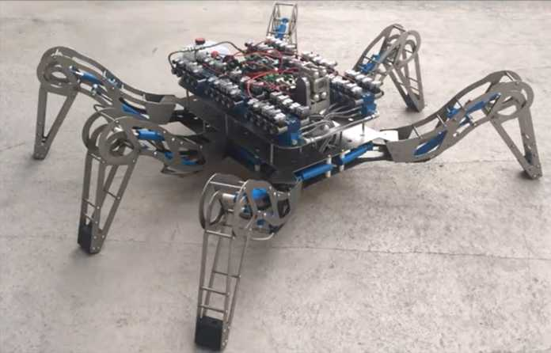
The design is to be made small enough to fit inside a 36inch diameter pipe to patch weld steel pipe. This will save companies the need to send human teams to investigate and patch pipes which can be a very costly exercise especially where extensive excavations are required to even gain access to the pipe. This could likely save adopters of the companies millions as individual repairs can cost upwards of £200k with large companies having to do repairs like this several times a year. The design still has a long way to go before it will be made commercially available with development of the bot due to be completed in January 2021.

Full story - http://www.constructionmanagermagazine.com/news/world-first-pipeline-repairing-robot-be-launched/
Company Website - https://fswbot.co.uk/

Exoskeletons

Exoskeletons have always seemed like something out of science fiction but not anymore. As technology advances the practicalities and applications of things like exoskeletons become more and more cost effective. The applications range from giving the disabled a chance to walk again to reducing strain on anyone with a manual labour element of their work. This makes the technology particularly exciting for the construction industry which has been plagued by musculoskeletal disorders which this technology could prevent.

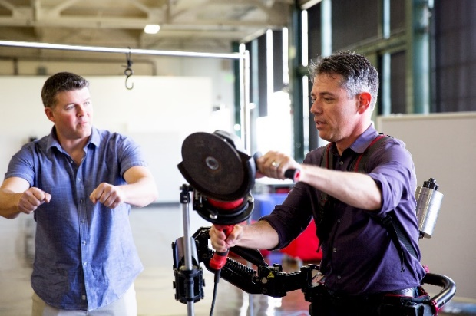
Some models of exoskeleton required a battery in order to move the machinery and are superior in the weights and loads that they can carry but currently have very limited battery life due to current battery technology and the efficiency of the mechanisms, as the technology progresses these systems will become more efficient and batteries will improve increasing the practicalities of battery powered exoskeletons. Other models are spring loaded that would be easily used by workers whilst needing no power supply, they would simply spread the load and reduce strain on the body. Currently this technology is being trialled in the New Zealand meat industry with promising results. There are many companies working on many different approaches to make the technology sleeker, cheaper and have more practicalities. We may not be as far off a working iron man suit as you might think, we can only hope.

News coverage - https://www.wired.com/2015/04/try-new-exoskeleton-construction-workers/ ;
https://www.constructiondive.com/news/weve-got-your-back-7-construction-exoskeletons-you-should-know-about/567742/
https://www.constructormagazine.com/suit-up/
YouTube demonstration - https://www.youtube.com/watch?v=Z_pdZ1LW5iw

3D printed revetment wall

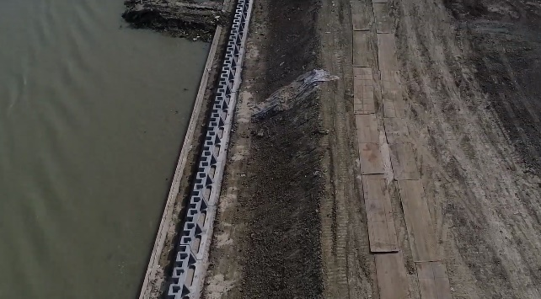
Chinese company WinSun recently completed what they claim to be the world’s largest 3D printed structure. The 432m long wall was constructed along the banks of a river in the town of Suzhou in the northern outskirts of Shanghai. The wall, which is about 1.5m in height, creates a flood defence system for the town. The construction of the wall consisted of sections which were printed and then lifted into place by crane and secured by an operative on the ground. WinSun have been developing 3D printing technology since 2008 and previously made headlines when they printed 10 homes in a day for less than $5,000 each. 3D printing technology has come a long way in construction since its inception and now has very real-life benefits to meet the housing crisis in several countries. In 2017 they partnered with Aecom to deliver 1.5 million houses in Saudi-Arabia.
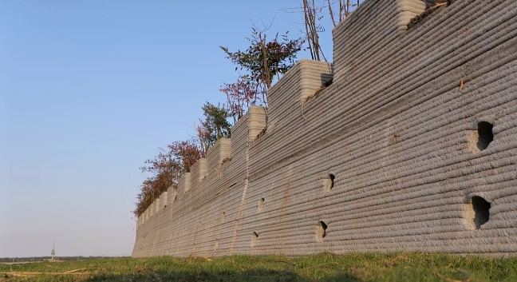
Full Story - http://www.globalconstructionreview.com/news/chinese-3d-specialist-completes-worlds-largest-pri/#read

Tips for a Safe Christmas
- Make sure that plugs aren’t damaged, sockets aren’t overload, and cables aren’t frayed.
- Keep flammable items away from fire hazards, such as tinsel near candles.
- Use a suitable stool or stepladder when donning your tree with a star or angel.
- When opening a box or packaging, avoid using a knife (use scissors instead). Make sure you always cut away from yourself.
- If you have children, keep an eye out for small bulbs or hooks that fall off Christmas decorations – they can be a choke hazard.
- When having a festive bake sale, make sure you label any allergens (such as nuts!).
- Turn off Christmas lights when you go to bed and blow out any candles.
- Check your smoke alarms and avoid the temptation to pinch batteries out of them.
- Keep cables out of walkways to prevent people from tripping.
- Take your time when preparing Christmas dinner so you don’t rush. You might accidentally knock a pot of boiling water or a knife!
- But most of all enjoy yourself, have a very merry Christmas and a happy new year!
Alliance CDM
The Station Master’s Office
Station Road
South Queensferry
EH30 9JP
TEL: 0131 319 2100
www.alliancecdm.co.uk

